GRACE FIRST BAPTIST CHURCH
2514 OBSERVATION DRIVE San Antonio, Texas 78227

Rev Allen Ford, Pastor
2019
LINWOOD F. RUSS
MEMORIAL SCHOLARSHIP GUIDELINES
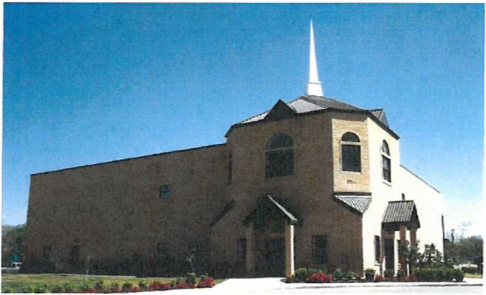

Deadline for submission: First Year Scholarship: May 19, 2019
Second Year Scholarships: June 09, 2019

"The heart of the prudent getteth knowledge; and the ear of the wise seeketh knowledge" Proverbs 18:15

Founder of Grace First Baptist Church
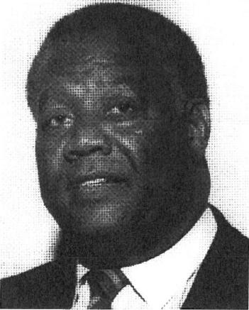
Reverend Linwood Fleming Russ
1931-1986
Rev. Linwood Fleming Russ organized and built Grace First Baptist Church, serving as the first Pastor. It was organized on June 6, 1975. God gave Rev. Russ the name "Grace" in a vision based on his favorite and most comforting scripture: "For by grace are ye saved through faith; and that not of yourselves; it is the gift of God. Not by works, lest any man should boast, for we are His workmanship, created in Jesus Christ unto good works, which God hath before ordained that we should walk." (Ephesians 2:8-10).
Rev. Russ graduated from Hillside High School in Durham, North Carolina. He attended North Carolina Central University also in Durham. He joined the United States Air Force in1954 and retired after twenty-two years of honorable service. Rev. Russ earned his Bachelor's Degree in Business Administration from St. Mary's University in San Antonio, Texas. He graduated from the Guadalupe Baptist Theological Seminary in San Antonio, Texas, and earned a Master's of Divinity from O'Blake College in San Antonio. Rev. Russ married Sister Blanche A. Russ and they had two children, Audrey and Linwood Carlton Russ.
An avid reader, Bible Scholar and God-fearing man, Rev. Russ was a visionary. He was always concerned about the wellbeing of mankind and placed priority on the youth and the elderly. His pleasing personality and love for mankind were his shining qualities, which contributed to a harmonious and respectful relationship with both his congregation and the community.
The vision God gave to Rev. Russ was clear and he knew he must be about his Father's business by working while it was day, because he knew night would come and he would not be able to work anymore. Night came for our loving founder and pastor on Saturday morning May 16, 1986.
The Linwood F. Russ Memorial Scholarship was established in honor of the late Rev. Linwood F. Russ, founder and first Pastor of Grace First Baptist Church in 1985. The Russ Family and friends initially funded the scholarship. In 1989 the church body of Grace First Baptist Church assumed the responsibility for funding the scholarship. A scholarship committee was appointed by the Pastor to administer the scholarship program. Please contact Sister Mary Hall at 210-681-5359 if you have questions about the scholarship.

LINWOOD F. RUSS MEMORIAL SCHOLARSHIP GUIDELINES

PURPOSE: To provide financial assistance to all Graduating Seniors of Grace First Baptist Church. This initiative promotes encouragement to Grace First Baptist Church Graduating Seniors who have been faithful to the church, The Youth Department and its activities. These incentives will be awarded in the form of Scholarships and/or Grants in the following categories: Four year or two year college, university or technical school. Graduating seniors who have chosen to enter the military or become employed will receive a one time Incentive Award.

CRITERIA:
- Applications must be typed.
- No handwritten applications will be accepted.
- Selection for awards shall be based upon the following:
- Church membership
- Completed application
- Scholastic Achievement (GPA)
- Letters of Recommendation
- Interview with Scholarship Committee
- Participation in Youth Department Activities
- No Handwritten Applications

DUTIES OF SCHOLARSHIP COMMITTEE ARE TO:
- Establish and maintain guidelines governing the Grace First Baptist Scholarship.
- Design and revise strategies for evaluating applicants in an objective manner.
- Annually publicize the scholarship program.
- Annually select applicants to receive the funds.
- Periodically evaluate the guidelines.
- Verify applicant and applicant's parent's or guardian's church membership with the Executive Assistant to Pastor.
- Acknowledge receipts of all applications in a timely manner.
- Determine the amount of disbursements.
- Determine the Scholarship and Grant Budget.

TERMS OF SCHOLARSHIP/GRANT FUND
- The scholarship or grant funds, regardless of amount will be made payable to the institution ONLY, not to the student. Only funds for the Linwood F. Russ ‘Incentive Award” will be made payable to the student.
- Funds will be distributed per semester in two equal payments. No funds are distributed for summer or special sessions.
- The awarding of funds will be based on Grace First Baptist Church Committee’s scoring guidelines.
- Upon award notification, applicants will receive further instructions regarding distribution of funds and required documentation.
  - Students MUST maintain a minimum GPA of 2.0 while in college.
  - Students must submit a copy of their transcript with GPA and a copy of courses enrolled after each semester. Funds WILL NOT be distributed without proper documentation.

- ALL applications must be placed in scholarship box

ELGIBILITY PERIOD:
- Scholarships are only for two years based on certain criteria.
- Grants are awarded for one year only.
- Incentive awards are Awarded for none year only.

AWARDS

FIRST YEAR SCHOLARSHIP
- Applicant must be a member of Grace First Baptist Church and an ACTIVE member of the Youth Department for at least ONE year.
- At least one parent or guardian must be a member of Grace First Baptist Church for at least ONE year.
- Applicant must be a high school graduate in the year the student applies for the scholarship.
- Applicant must be accepted and plan to attend an accredited two (2) year or four (4) Year college/ university in the fall semester immediately following graduation from high school.
5. Applicant who attends a Technical school Must attend in the fall semester immediately following graduation from high School.
6. Applicant must have a minimum High School GPA of 2.0 on a 4.0 scale or equivalent.
GRANT INITIATIVE (ONE YEAR ONLY)
- Applicant must be a member of Grace First Baptist Church and an ACTIVE member of the Youth Department less than one year.
- Applicant must be a high school graduate in the year the student applies for the scholarship.
- Applicant must be accepted and plan to attend an accredited two (2) year, four (4) year college/ university in the fall semester immediately after graduating from high school.
- Applicant who plans to attend a Technical School Must plan to attend in the fall semester immediately after graduating from high school.
- Applicant must have a minimum High School 2.0 GPA on a 4.0 scale or equivalent

LINWOOD F. RUSS INCENTIVE AWARD
Graduating Seniors who have been faithful to Grace First Baptist Church and the Youth Department who choose to go into the military or join the work force will receive a one-time award. Disbursement of funds will be after one of the above condition are met. (Not more than three months after graduation)

SECOND YEAR SCHOLARSHIP CONTINUATION (SOPHOMORE YEAR)
- Applicant must be a recipient of the First Year Scholarship
- Applicant must maintain his/her membership at Grace First Baptist
- Applicant must demonstrate completion of the first and second semesters of college with an overall GPA of 2.0 or equivalent and at least 24 accredited course hours.
- Technical School applicant must demonstrate completion of the first and second semesters with an overall GPA of 2.0.
- Applicant must submit the second year application along with your class. schedule from an accredited college or university immediately following the completion of the first year.

APPEALS
An APPEAL May Be Submitted if circumstances are justifiable!!!
The appeal should include:
- A type written letter justifying the reason for an appeal.
- This letter must show validation that the student is eligible to enroll.
- Student may show a Letter/statement from attending physician.
- Student must show proof of enrollment.
- Student must be available for an interview with the scholarship committee upon request.
- In the case of an untimely death of an immediate family (mother, father, sister, brother, grandmother or grandfather) a program copy will be accepted.

DISBURSEMENTS:
The presentations of these awards will take place during a Sunday morning service at Grace First Baptist Church.

SCORING CATEGORIES
CATEGORY: MAXIMUM POINTS
- Church Membership 10 points
- Involvement in GFB Church Youth Activities 40 points
(Based on letter from GFBC Youth Director)
- Grade Point Average (GPA) 30 points
- Foundations of Christian Living 10 points
- Interview with Scholarship Committee 10 points

REQUEST FOR FALL DISBURSEMENTS:
To ensure funds are received in a timely manner:
- Scholarship recipient MUST complete school registration
- Scholarship recipient MUST complete a “Request for Fall Distribution.”
- Scholarship recipient MUST submit both documents to the Scholarship Chairperson.

REQUEST FOR SPRING DISBURSEMENT:
To ensure funds are received in a timely manner, student must submit the following documents 10 days prior to the the spring semester start date.
- Scholarship recipient MUST submit Fall grades representing a GPA of 2.0 or greater and at least 12 semester credit hours.
- Scholarship recipient MUST submit spring course schedule representing a minimum of at least 12 semester hours.

DOCUMENT DEADLINES:
First Year: NOON SUNDAY; MAY 19, 2019
Second year: NOON SUNDAY; JUNE 09, 2019

Scholarship Application Packets MUST be placed in the Scholarship Mail box located in the church office by Noon, Sunday, May 19, 2019

NO EXCEPTIONS

If you have additional questions contact Sis Mary Hall, Chairperson, Linwood F Russ Scholarship Committee at: 210-487-9761

GRACE FIRST BAPTIST CHURCH
LINWOOD F. RUSS MEMORIAL SCHOLARSHIP
(FIRST YEAR SCHOLARSHIP AND GRANT APPLICATION)
I. APPLICANT INFORMATON I
NAME DATE
ADDRESS
CITY / STATE / ZIP
HOME PHONE CELL PHONE
E-MAIL ADDRESS
PARENT /GUARDIAN'S NAME

PARENT /GUARDIAN'S HOME PHONE CELL PHONE
PARENT/GUARDIAN'S E-MAIL ADDRESS
PARENT/GUARDIAN'S HOME ADDRESS, IF DIFFERENT
II. CHURCH MEMBERSHIP I

- DATE YOU JOINED GRACE FIRST BAPTIST CHURCH:
- IS PARENT/GUARDIAN A MEMBER OF GRACE FIRST BAPTIST CHURCH? YES NO
- IF YES, DATE MEMBER JOINED
IIII. CHURCH INVOLVEMENT

A. LIST ACTIVITIES YOU HAVE PARTICIPATED IN WHILE AT GRACE FIRST BAPTIST CHURCH.

- LIST ANY LEADERSHIP POSITIONS YOU HAVE HELD WHILE AT GRACE FIRST BAPTIST CHURCH.
- WHAT ACTIVITY OR AUXILIARY HAS HELPED YOU THE MOST IN YOUR RELIGIOUS DEVELOPMENT? EXPLAIN.

IV. EDUCATION INFORMATION I

- NAME OF CURRENT HIGH SCHOOL:
- DATE OF ANTICIPATED GRADUATION:
- NAME OF COLLEGE YOU PLAN TO ATTEND IN THE FALL:
- HAVE YOU RECEIVED YOUR COLLEGE ACCEPTANCE LETTER? Yes ________No________________________
- LIST THE HIGH SCHOOL EXTRA-CURRICULAR ACTIVITIES IN WHICH YOU HAVE PARTICIPATED
- FRESHMAN YEAR:
- SOPHOMORE YEAR:

- JUNIOR YEAR:
- SENIOR YEAR:
F. HAVE YOU HELD ANY LEADERSHIP POSITIONS IN HIGH SCHOOL?
IF YES, INDICATE WHICH POSITIONS YOU HAVE HELD OR HOLD.
V. CHRISTIAN FOUNDATION: I

READ THE FOLLOWING SCRIPTURES: Ephesians chapter 4, Galations chapter 5 and Romans chapter 8. Comment on the following :
- As a graduating senior preparing to leave home, what spiritual tools or qualities will you use as a guide for your spiritual growth in years to come?
- How does the Apostle Paul describe the "old self'? What are its traits?
- According to Apostle Paul, as Children of God, how should you walk?

- Grace First Baptist Theme for 2019 is “Connecting People”. What does this mean to you?
- As Christians, our daily duty is to minister and spread the word of Christ. As you leave on your journey to college, how will you minister and connect with others to spread the word of Christ?
REQUIRED DOCUMENTATION
Applicants must include the following documents with the application and place the sealed package in the Scholarship Committee's mailbox (located in the church office) by 12 noon, Sunday, May 19, 2019. The following documents MUST be included or applicant will be disqualified.
- Completed /signed application
- Official High School Transcript (sealed)
- Three Letters of Reference from the following:
> The Pastor of Grace First Baptist Church
- The Youth Director of Grace First Baptist Church
- A High School Counselor or High School Teacher

Linwood F. Russ Memorial Application
AGREEMENT
This agreement is the final page of the FIRST YEAR SCHOLARSHIP/ GRANT application package. Please sign and date as appropriate below. Both signatures are required,
I (student) have carefully read and understand
ALL terms and conditions for a Linwood F. Russ Memorial First Year Scholarship and One year Grant.
I (parent/guardian) have worked closely with my
Son/ daughter during this educational experience and ensure compliance of application requirements.
Date
Signature of Applicant
Date
Signature of Parent/Guardian

